CRUD in React JS

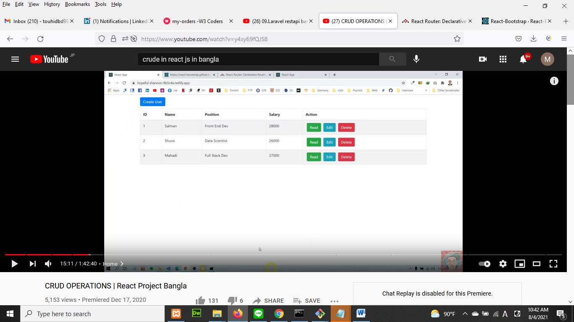

Step:1 Installation/Create Project

////Project of React////

1. **create new project** of React: npx create-react-app crud_react
2. login react project: cd crud_react
3. run react project: npm start
4. open vscode: code .
5. After finish project when need to upload to cpanel then we need to build project: npm run build

When build build complete go to your project, you will see a “build” folder. You can upload your project to a free site “netlify.com”. singnup to netlify.com (email and pass)

Step:2

Go to browser: react bootstrap

1. react bootstrap: npm install react-bootstrap bootstrap
2. Add bootstrap css in index.js file: import 'bootstrap/dist/css/bootstrap.min.css';

Step: 3 add react **route**

browser: reactrouter.com ==> web

copy: npm install react-router-dom (install it)

copy: BrowserRouter as Router,

Switch,

Route,

Link

We need to make App.js file as a route file, so In App.js file write below way

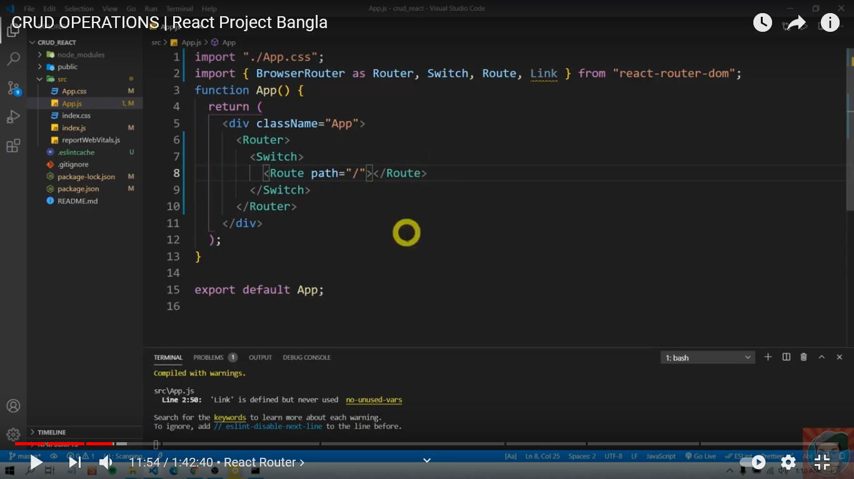

Step:4 **View** User **Data** in Home page

Right click on “src”🡺create a folder “components”. Inside component create a folder “Home”. Create two file 1. Home.css, 2. Home.js . now open Home.js file write below way code

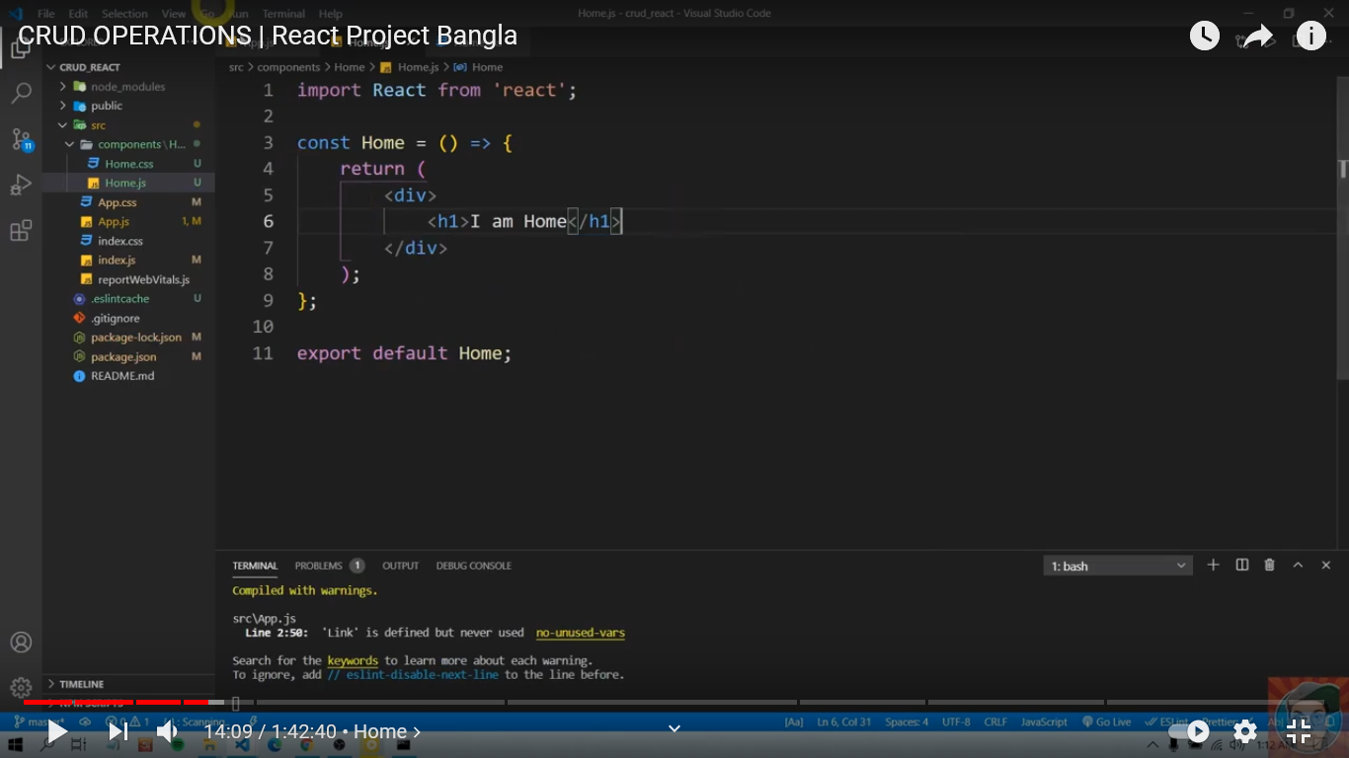

Step:5 **Set Home age as Index page (default page)**

go to App.js (route file) and write below way code (add home page as default/index page).

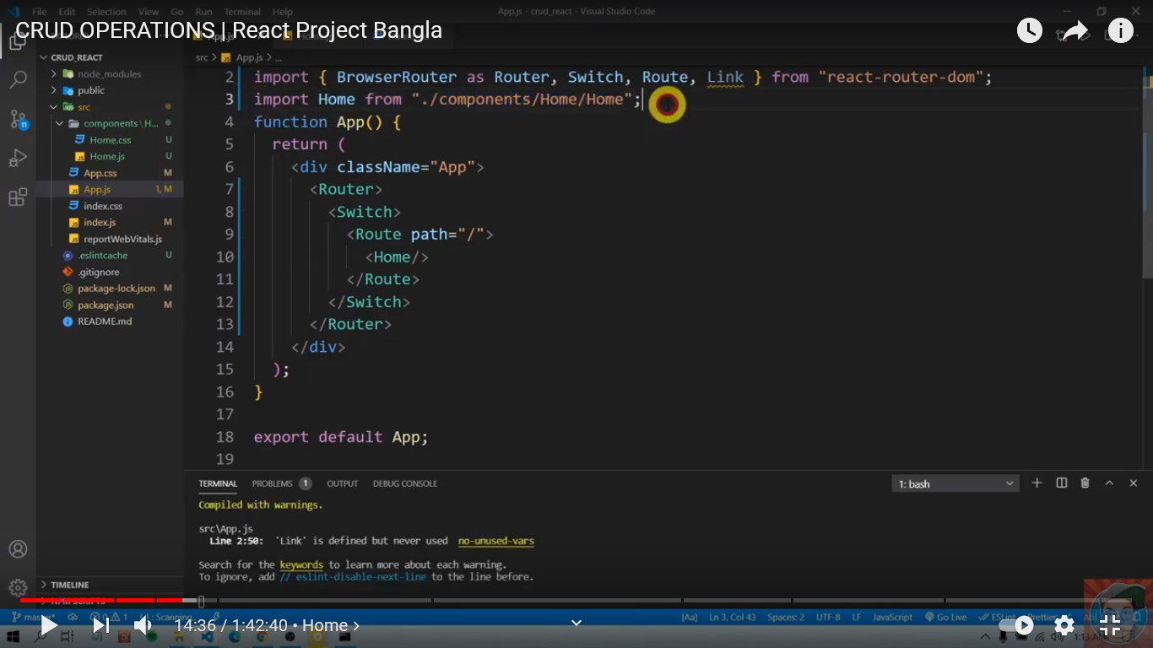

Step: 6 **Home page Design**

suppose we will set a button and a table in our home page like below



For above task, we need to import button and table (browser: react-bootstrap) and add in home page like below

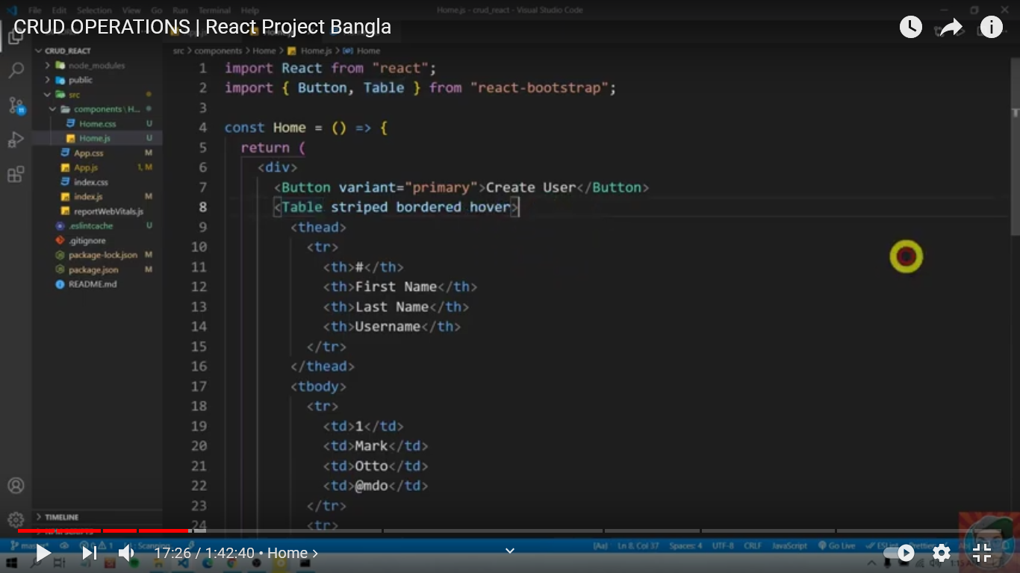

1. First Import

import { Button,Table } from 'react-bootstrap';

1. Add element in function (const Home = ()=>{ return( <div> your element </div>)})

<Button variant="primary">Create User</Button>

<Table striped bordered hover>

<thead>

<tr>

<th>#</th>

<th>First Name</th>

<th>Last Name</th>

<th>Username</th>

</tr>

</thead>

<tbody>

<tr>

<td>1</td>

<td>Mark</td>

<td>Otto</td>

<td>@mdo</td>

</tr>

</Table>

Step:7 **Controller**

Now we need to create context api(Controler) to send data to our home page table.

In “src”, create folder “UserContext” and create a file “UserContext.js”(userController) in side UserContext folder.

Type the below code in **UserContext.js** (userController) file

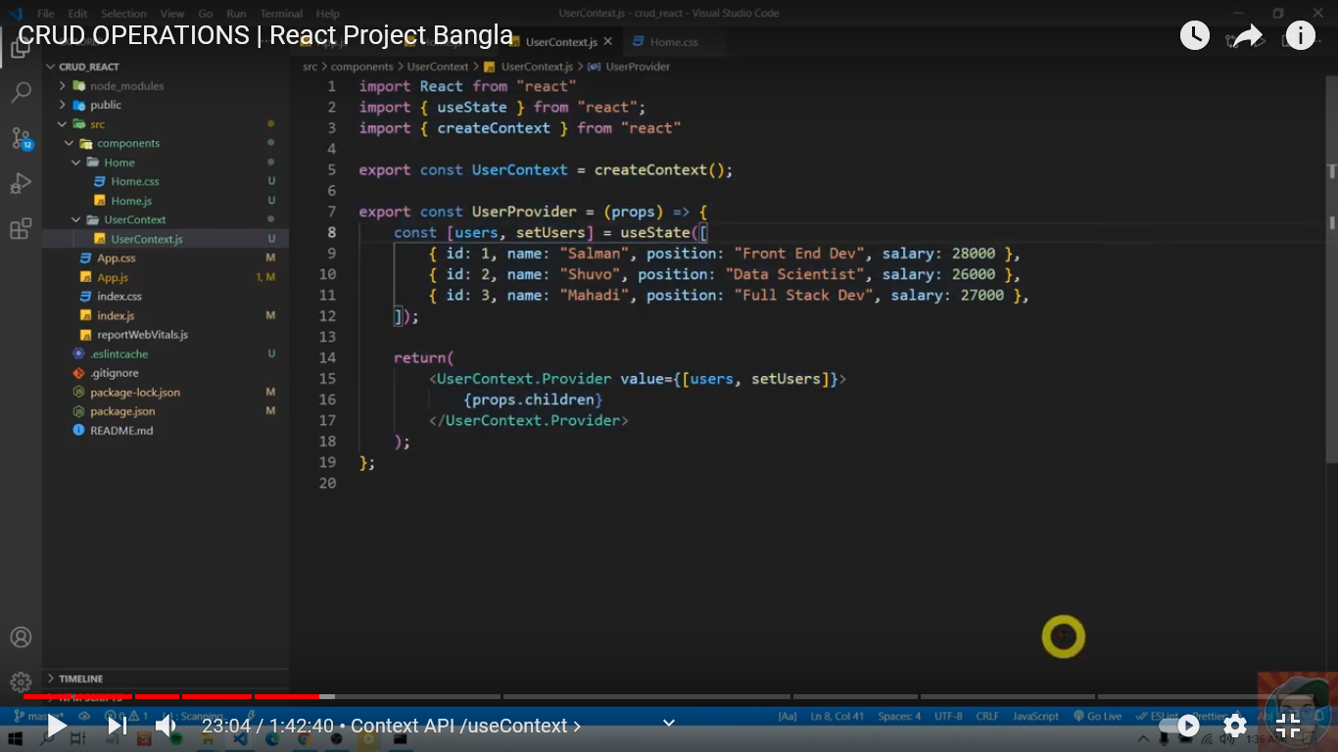

Step:8 **set controller in route**

set **<userProvider>**(controleler) in **app.js** (route) file

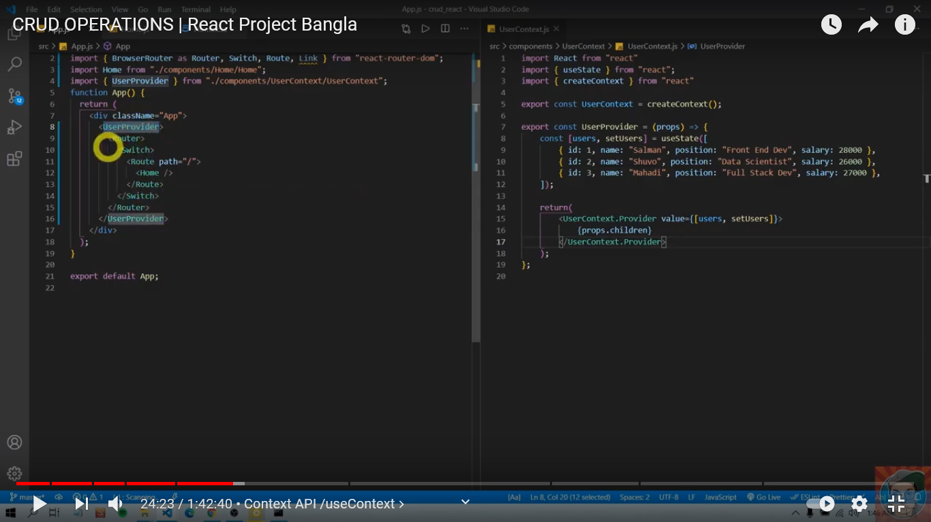

Step:9 **View data** that are coming from **UserProvider** (controller)

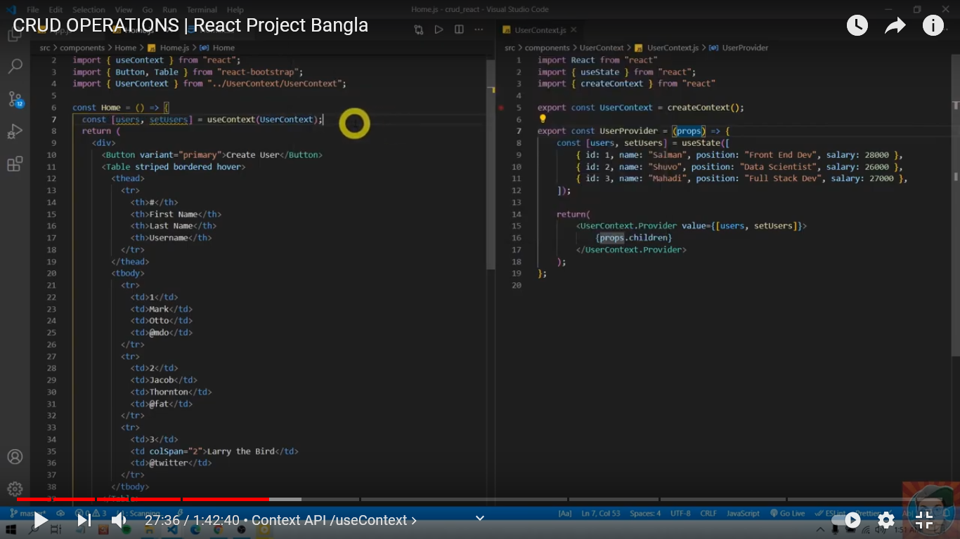

We will write map function (foreach loop) like below

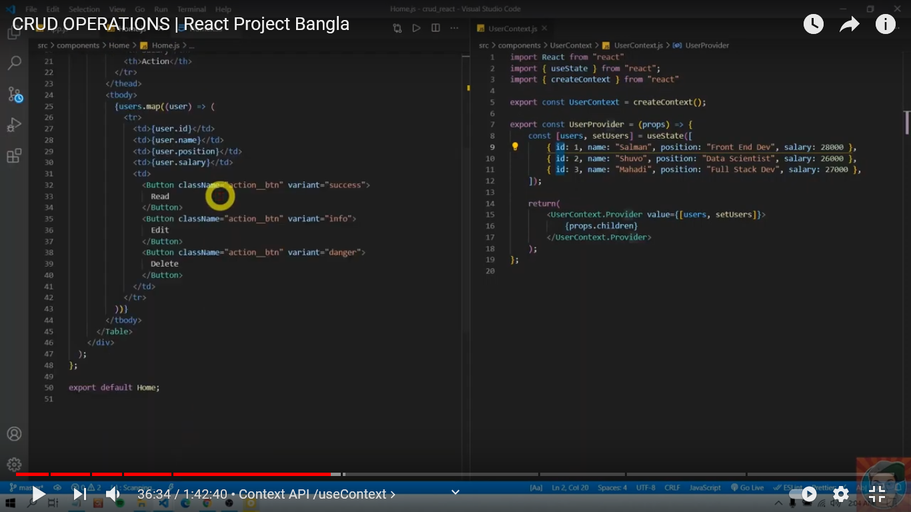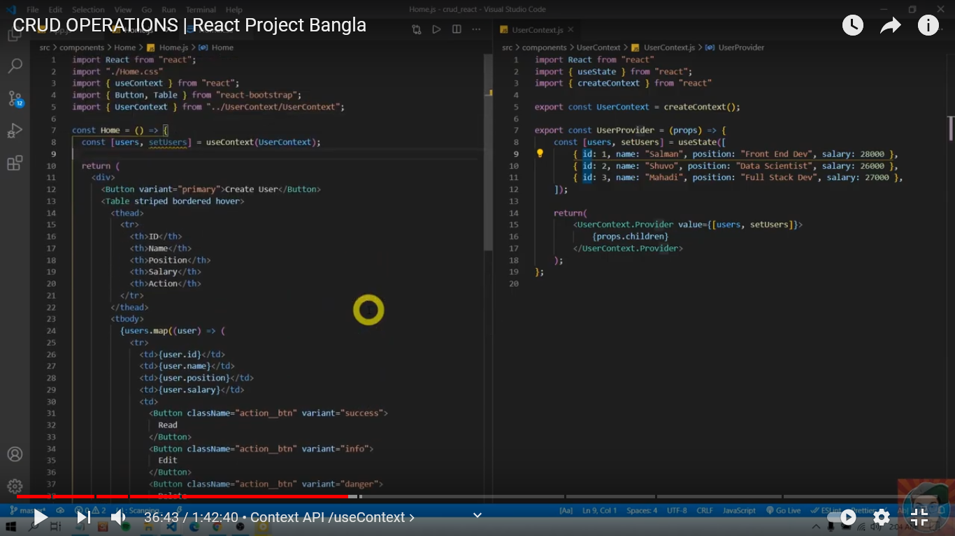

Step:10 **Delete Data**

To delete data, we need to do 4 task

1. Create Delete Component
2. Add Delete component in Route
3. Call delete route path from Home Page Table
4. Delete function

**Create Delete Component:**

In “src”, go to “components” folder. Create folder “Delete” inside “components”. Create a two file “Delete.js, Delete.css” inside “Delete” folder.

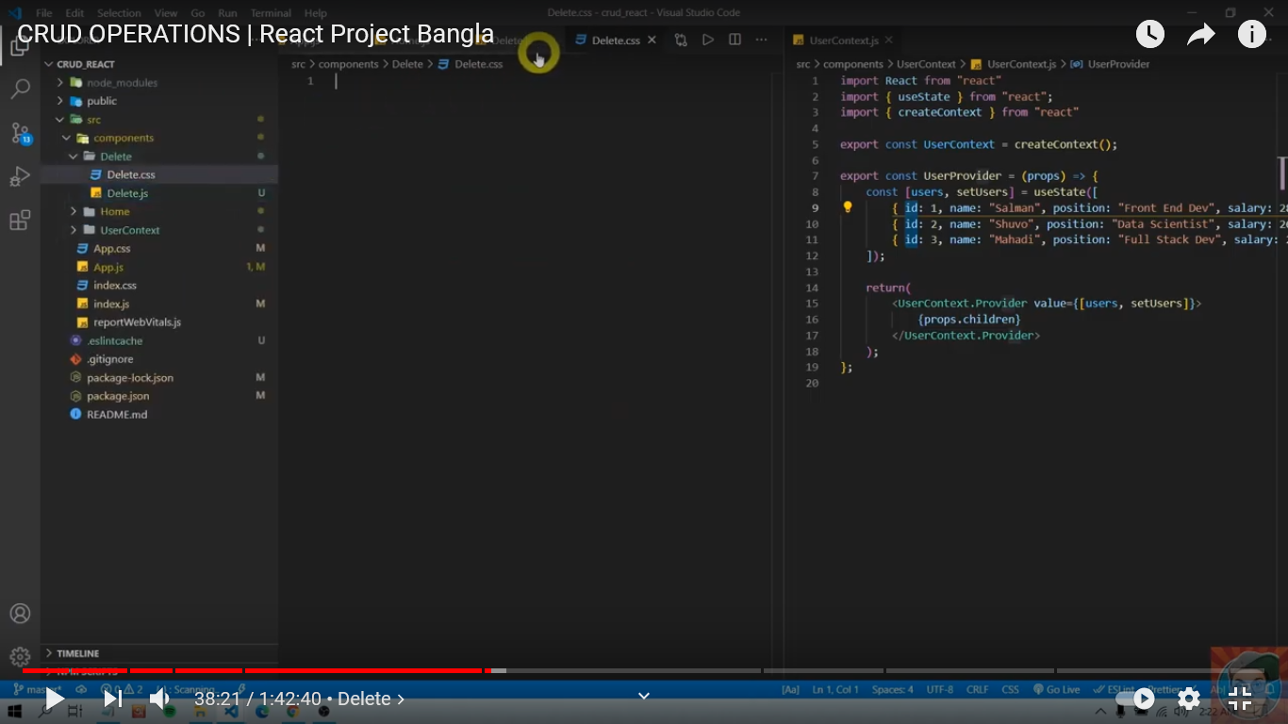

**Add Delete Component in Route(App.js):**

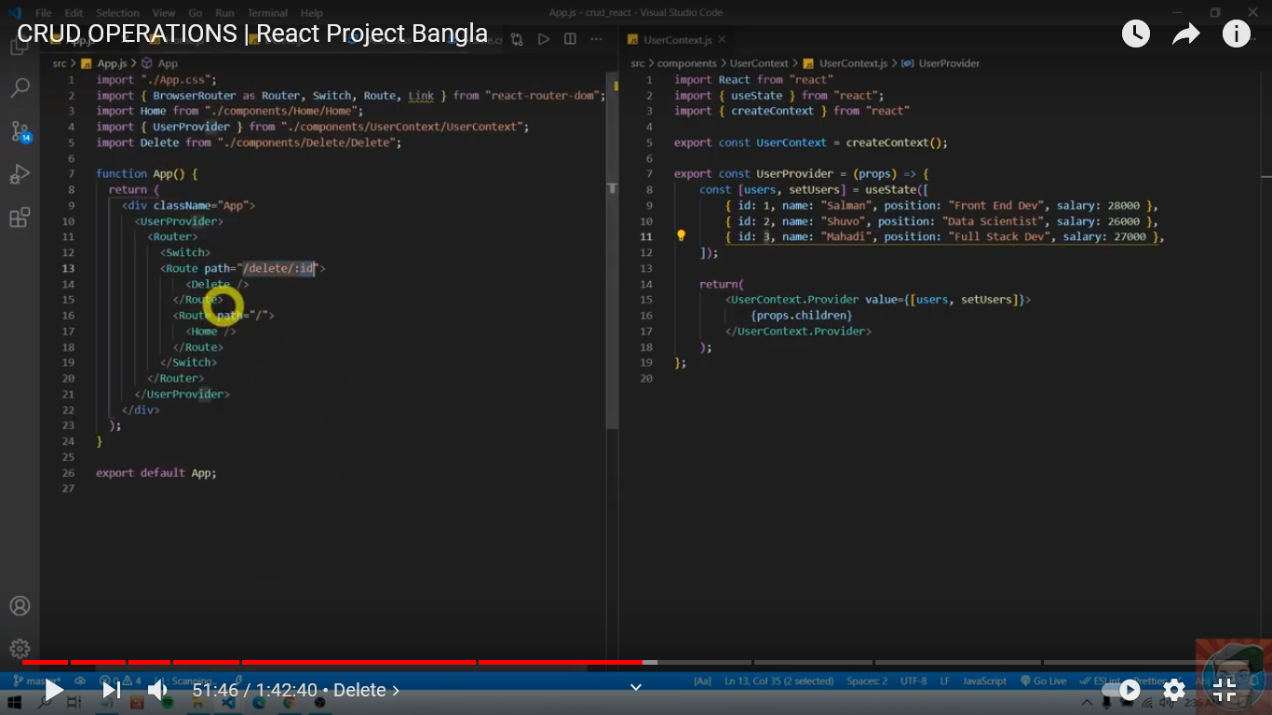

Call Delete Route from Home page(Home.js) Table

1. Import link at the top

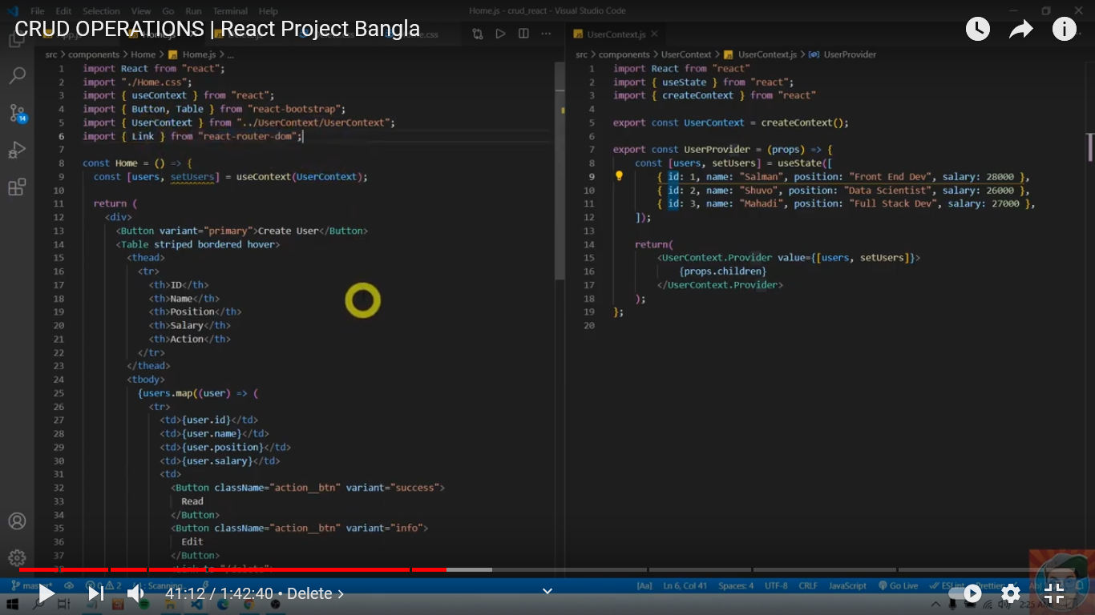

1. Add delete route link

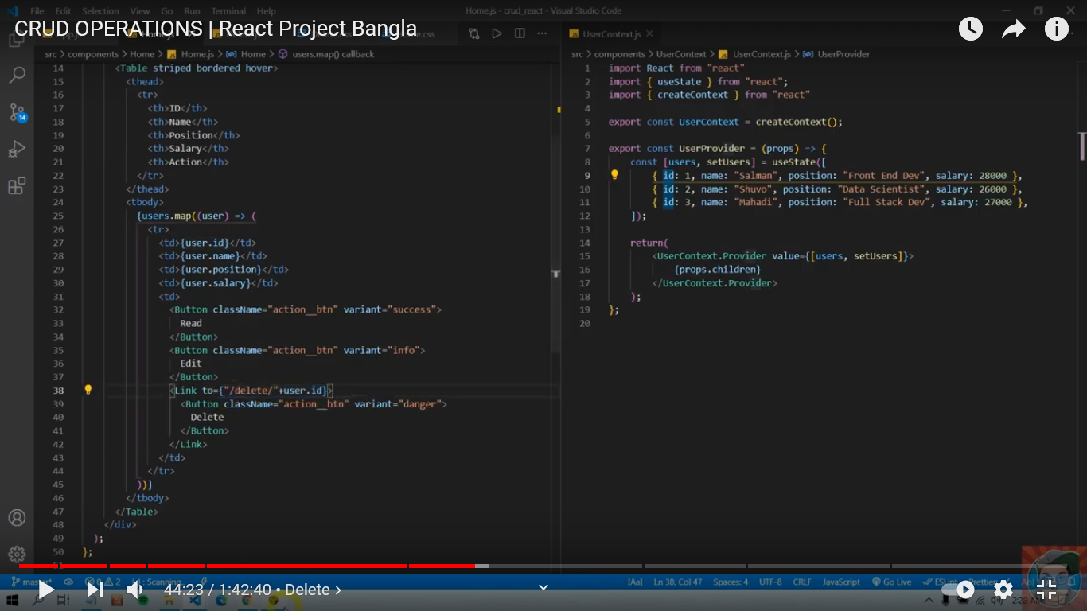

In “Delete.js” page write below way code

1. Connect controller
2. Get parameter that passed from Home.js page
3. Delete Data by filter function
4. Return message

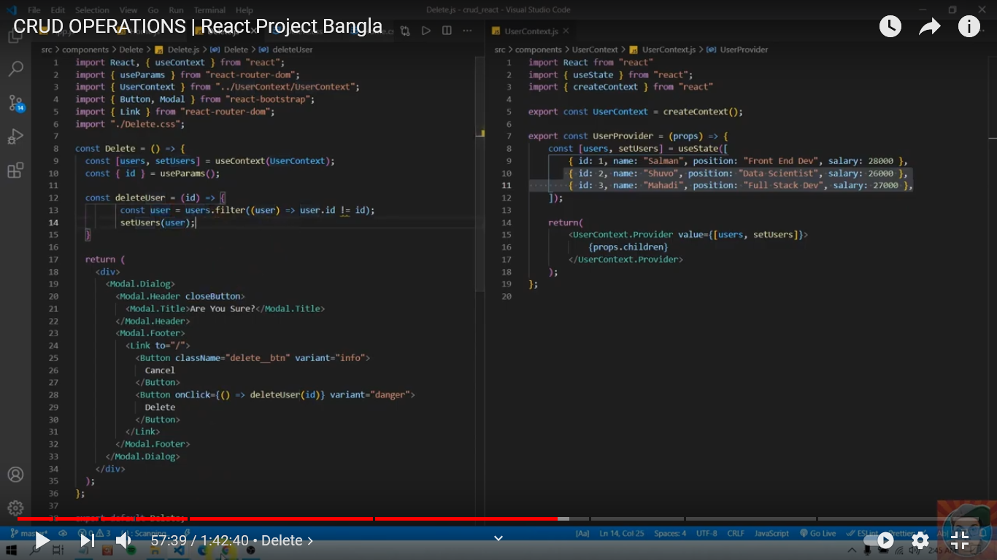

Step:11 **ViewDetais Data**/read data

To Read data, we need to do 4 task (Follow Delete Data)

1. Create Read Component
2. Add Read component in Route
3. Call Read route path from Home Page Table
4. Read function in Read.js page

**Create Read Component:**

In “src”, go to “components” folder. Create folder “Read” inside “components”. Create a two file “Read.js, Read.css” inside “Read” folder.

**Add Read Component in Route(App.js):**

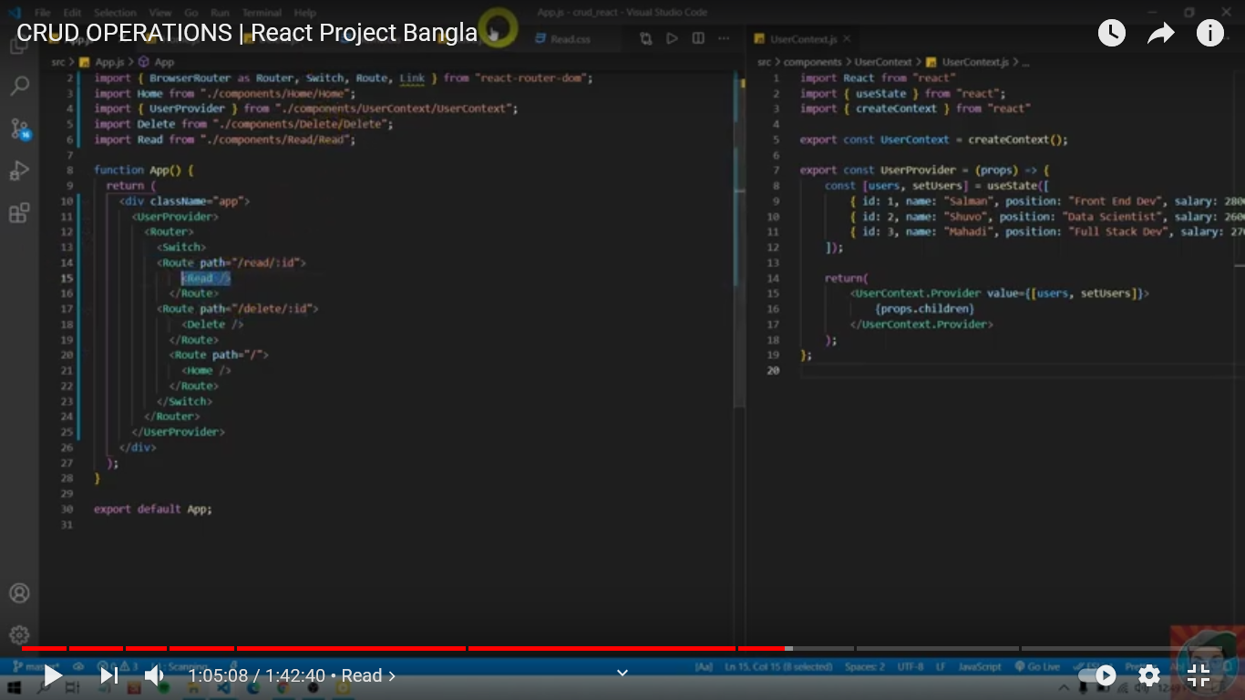

**Call Read route path from Home Page (Home.js) Table:**

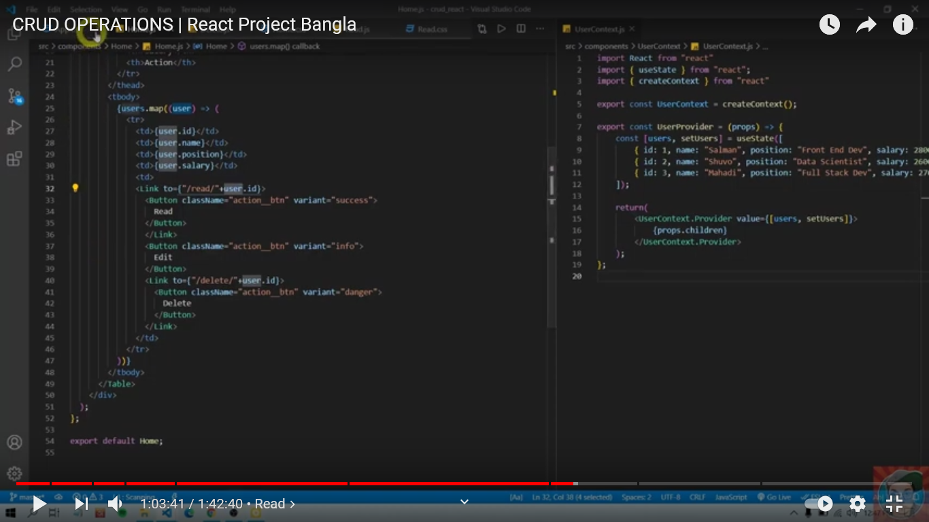

**Read function in Read.js page:**

1. Controller/provider connection
2. Data pass
3. Get data
4. Set data in return section

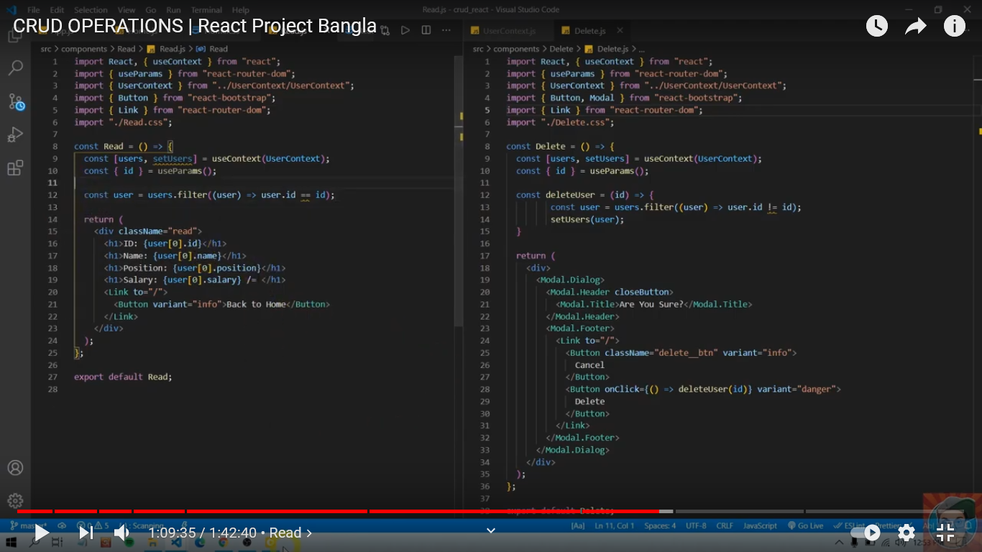

**Create/Insert Data**

1. Create Component
2. Add Component in Route
3. Link route in Home Page
4. Create Page function

**Create Component:**

In “src”, go to “components” folder. Create folder “Create” inside “components”. Create a two file “Create.js, Create.css” inside “Create” folder.

**Add Component in Route (App.js)**

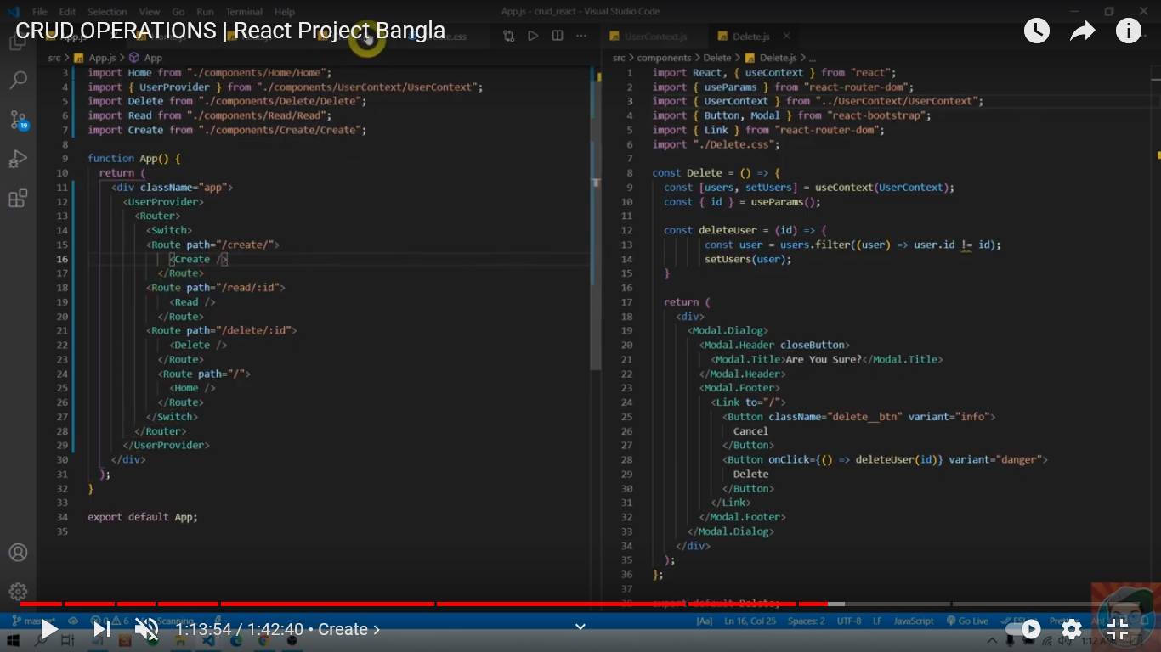

**Link route in Home Page (Home.js)**

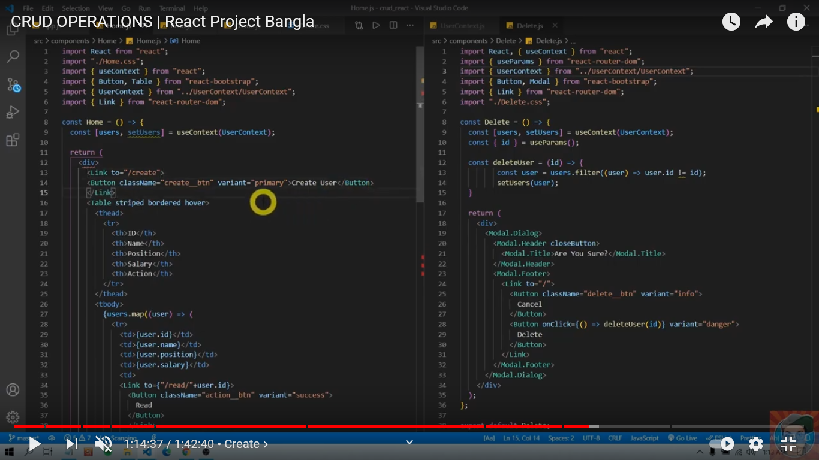

Create Page function

